The Stock Exchange of Hong Kong Limited takes no responsibility for the contents of this announcement, makes no representation as to its accuracy or completeness and expressly disclaims any liability whatsoever for any loss howsoever arising from or in reliance upon the whole or any part of the contents of this announcement.

This announcement, for which the directors of Zhongyu Gas Holdings Limited (“the Company”) collectively and individually accept full responsibility, includes particulars given in compliance with the Rules Governing the Listing of Securities on the Growth Enterprise Market (“GEM”) of The Stock Exchange of Hong Kong Limited for the purpose of giving information with regard to the Company. The directors of the Company (the “Directors”), having made all reasonable enquiries, confirm that, to the best of their knowledge and belief:- (1) the information contained in this announcement is accurate and complete in all material respects and not misleading; (2) there are no other matters the omission of which would make any statement in this announcement misleading; and (3) all opinions expressed in this announcement have been arrived at after due and careful consideration and are founded on bases and assumptions that are fair and reasonable.

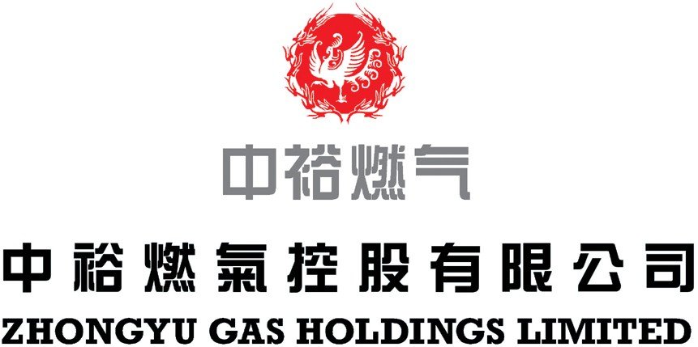
(incorporated in the Cayman Islands with limited liability)

(Stock Code: 8070)

NOTICE OF BOARD OF DIRECTORS’ MEETING

The board of Directors (the “Board”) hereby announces that a meeting of the Board will be held at Suite 3016, 30th Floor, One International Finance Centre, 1 Harbour View Street, Central, Hong Kong on Friday, 10th November, 2006 at 4:00 p.m. for the following purposes:-

- To receive and consider the unaudited consolidated results of the Company and its subsidiaries for the nine months ended 30th September, 2006, and to approve the draft announcement of such results to be published on the GEM website;

- To consider the payment of dividend, if any;

- To consider the closure of the Register of Members, if necessary; and

- To transact any other businesses.

By order of the Board
Lui Siu Keung
Company Secretary

Hong Kong, 26th October, 2006

As at the date of this announcement, the Board comprises Mr. Wang Wenliang (Chairman), Mr. Hao Yu (Chief Executive Officer) and Mr. Lu Zhaoheng, being the executive Directors, Mr. Xu Yongxuan (Vice-Chairman), Mr. Wang Lei and Mr. Nicholas John Ashley Rigg, being the non-executive Directors and Mr. Wang Shunlong, Dr. Luo Yongtai and Mr. Hung, Randy King Kuen, being the independent non-executive Directors.

This announcement will remain on the “Latest Company Announcements” page of the GEM website at www.hkgem.com for at least 7 days from the date of its posting.

